**####**

Pharmacy Management System

**Interim Report**

**ICT2233 - Software Engineering**

**Submitted by:**

1. TG/2020/674 – Chandimal Priyamantha
2. TG/2020/707 – K.G.L.Nethsara Kiringoda
3. TG/2020/694 – H.A.R.N.Karunarathna
4. TG/2020/706 – K.G.S. Dissanayake
5. TG/2020/684 – M.A.D.A.M.Arachchi
6. TG/2020/747 – H.Tirasha Dinuki
7. TG/2020/676 – A.Asama
8. TG/2020/704 – T.Madusha

**Lecturer in charge:** Miss. Chanduni Gamage

**Submission Date:** 2023/00/00



Bachelor of Information and Communication Technology.

Department of Information and Communication Technology.

Faculty of Technology.

University of Ruhuna.

**Declaration**

“We certify that this project does not incorporate without acknowledgment, any material previously submitted for an assignment in any institution, and to the best of my knowledge and belief, it does not contain any material previously published or written by another person or myself except where due reference is made in the text. I also hereby give consent for my dissertation, if accepted, to be made available for photocopying and for interlibrary loans, and for the title and summary to be made available to outside organizations”.

Name Index No Signature

1. Chandimal Priyamantha TG/2020/674 …………………………
2. K.G.L.Nethsara Kiringoda TG/2020/707 …………………………
3. H.A.R.N.Karunarathna TG/2020/694 …………………………
4. K.G.S. Dissanayake TG/2020/706 …………………………
5. M.A.D.A.M.Arachchi TG/2020/684 …………………………
6. H.Tirasha Dinuki TG/2020/747 …………………………
7. A.Asama TG/2020/676 …………………………
8. T.Madusha TG/2020/704 …………………………

**Acknowledgement**

We would like to express our gratitude to all those who have contributed to the successful completion of this endeavor. Their unwavering support, guidance, and encouragement have been invaluable throughout this journey.

First and foremost, we extend our deepest appreciation to our head of the department for their guidance and constant supervision of Ms. Chanduni Gamage, whose expertise, patience, and dedication have been instrumental in shaping this project.

We wish to extend our thanks to all colleagues and friends who have been a constant source of motivation and camaraderie. Your discussions, brainstorming sessions, and moral support have been integral to this undertaking.

Table of Contents

**Chapter 1: Introduction**

1.1 Statement of the Problem

1.2 Aims and Objectives

1.3 Scope of the Project

1.4 Gantt Chart

**Chapter 2: System Analysis & Design**

2.1 Use case Diagram

2.2 Use case narratives

2.3 Activity Diagrams

2.4 Sequence Diagrams

2.5 ER diagram

2.6 Software Requirement Specification

**Chapter 3: Proposed System Design**

3.1 Architecture Design

3.2 Proposed System Interfaces

3.3 Report Designs

3.4 Test plan for the system

3.5 Proposed Software Engineering Methodology

**Conclusion**

**References**

List of figures

**Chapter 1: Introduction**

We propose to design and build a thorough pharmacy shop management application that will streamline business processes and ensure effective staff management, customer engagement, medication inventory control, precise financial tracking, formal communication facilities (email), remote medication distribution, and strong reporting capabilities. The app will target both small and large pharmacies and be user-friendly and accessible.

* 1. **Statement of the problem**

Due to manual processes, many small- and medium-sized pharmacies find it difficult to operate their business effectively, which causes mistakes in the management of inventory, customers, and finances.

Inefficiencies and significant revenue losses result from the lack of a centralized system for managing the inventory of medicines, customer information, and employee data.

* 1. **Aims and Objectives**

The project's goal is to provide a user-friendly, effective Pharmacy Shop Management Application that improves the workflow of pharmacy operations as a whole. The precise goals consist of:

1. Managing personnel Information: Create a module that makes it simple to handle personnel details such identities, responsibilities, and schedules.

2. Managing Customers: Create a customer management module that simplifies order history, communication, and customer registration.

3. Managing Medicine: Develop a module to check stock levels, expiration dates, and enable reordering alerts for medicines.

4. Managing Financials: Create a module for accounting and invoicing so that revenues, expenses, and client bills can all be tracked accurately.

5. Reporting: Create a reporting module that offers details on sales patterns, inventory turnover, profit margins, and other important performance metrics.

6. Formal Communication: Create a module that enables communication with clients and vendors.

7. Remote pharmaceutical Distribution: Create a pharmaceutical distribution module that offers consumers precise and efficient service.

* 1. **Scope of project**

1.Planning the project (Week 1):

- Specify the project's goals, objectives, and needs.

- Divide up team members' roles and tasks.

- Create lines of communication to facilitate productive teamwork.

|  |  |  |  |
| --- | --- | --- | --- |
| **Task** | **Duration (Days)** | **Start** | **End** |
| Planning the project | 07 | 19/08/2023 | 25/08/2023 |

2.Designing UI/UX (Week 2):

- Produce mockups and wireframes for the user interface of the program.

- Collect suggestions and improve the design for the best user experience.

|  |  |  |  |
| --- | --- | --- | --- |
| **Task** | **Duration (Days)** | **Start** | **End** |
| Designing UI | 07 | 26/08/2023 | 31/08/2023 |

3. Database design (Week 3):

- Create a database schema to contain information about the personnel, customers, medications, and finances.

- Ensure scalability and data integrity.

|  |  |  |  |
| --- | --- | --- | --- |
| **Task** | **Duration (Days)** | **Start** | **End** |
| Database Design | 07 | 26/08/2023 | 31/08/2023 |

4.Development on the front end (Week 4):

- Create user interfaces for different modules utilizing cutting-edge JavaFX technologies.

Develop a responsive design strategy.

|  |  |  |  |
| --- | --- | --- | --- |
| **Task** | **Duration (Days)** | **Start** | **End** |
| Development on the front end | 07 | 01/09/2023 | 07/09/2023 |

5.Development on the back end (Week 5):

- Create the essential logic and features of the program.

- Connect the front end to the back-end services and database.

|  |  |  |  |
| --- | --- | --- | --- |
| **Task** | **Duration (Days)** | **Start** | **End** |
| Development on the back end | 07 | 08/09/2023 | 14/09/2023 |

6. Quality assurance and testing (Week 6):

- Carry out exhaustive testing to find and address any flaws or problems.

- Ensure system stability and data security.

|  |  |  |  |
| --- | --- | --- | --- |
| **Task** | **Duration (Days)** | **Start** | **End** |
| Quality assurance and testing | 07 | 15/09/2023 | 21/09/2023 |

7.Documentation (Week 7):

- Produce thorough documentation for installation, upkeep, and user instructions.

|  |  |  |  |
| --- | --- | --- | --- |
| **Task** | **Duration (Days)** | **Start** | **End** |
| Documentation | 01 | 22/09/2023 | 29/09/2023 |

8.Deployment and Training (Week 8):

- Install the application on a client machine or hosting platform.

- Teach pharmacy personnel how to use the system efficiently.

|  |  |  |  |
| --- | --- | --- | --- |
| **Task** | **Duration (Days)** | **Start** | **End** |
| Select a client | 07 | 30/09/3023 | 06/10/2023 |

9.Finalisation and Presentation (Week 9):

- Check the application one last time to make sure all requirements have been completed.

- Create a presentation that highlights the features and functionality of the program.

|  |  |  |  |
| --- | --- | --- | --- |
| **Task** | **Duration (Days)** | **Start** | **End** |
| Select a client | 07 | 07/10/2023 | 13/10/2023 |

* 1. **Gantt Chart**

**Chapter 2: System Analysis and Design**

**2.1 Use case diagram**

**2.2 Use case narratives**

**2.3 Activity diagrams**

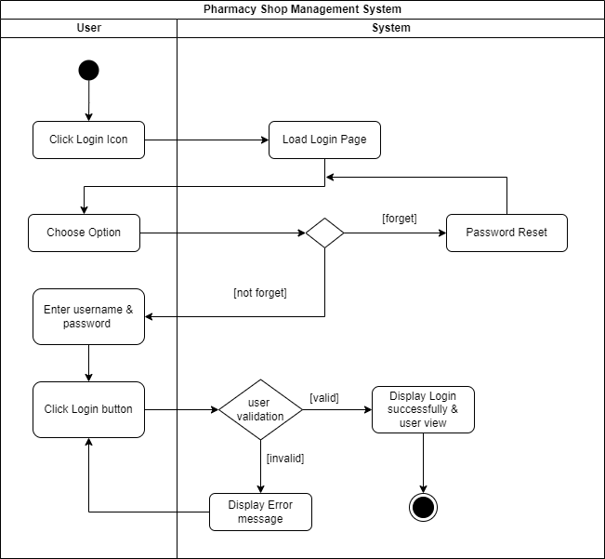

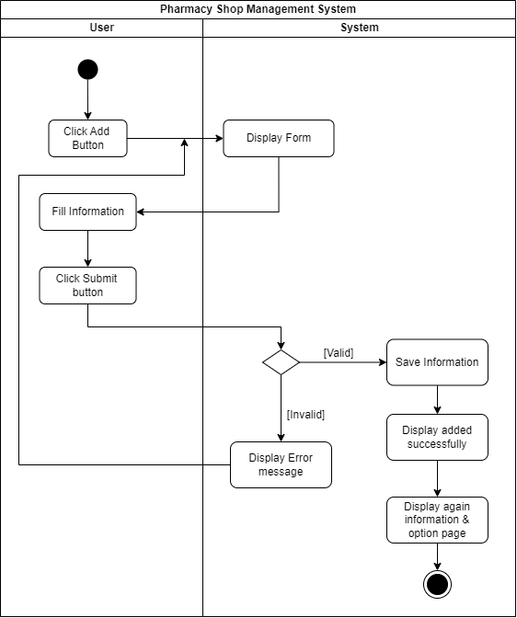

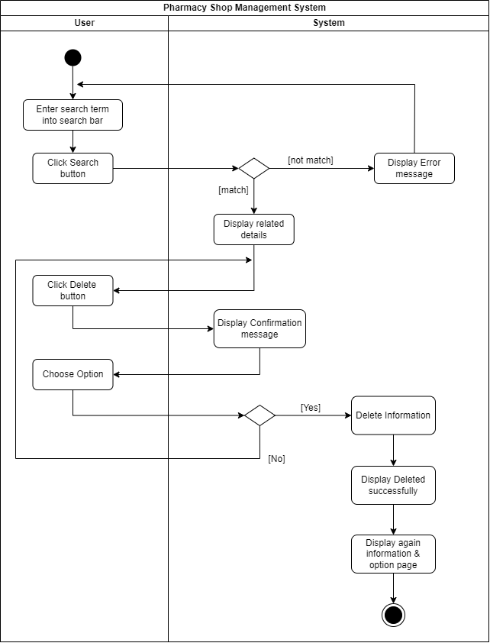

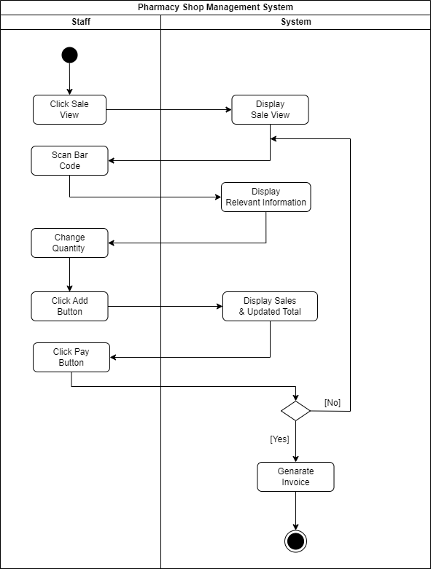

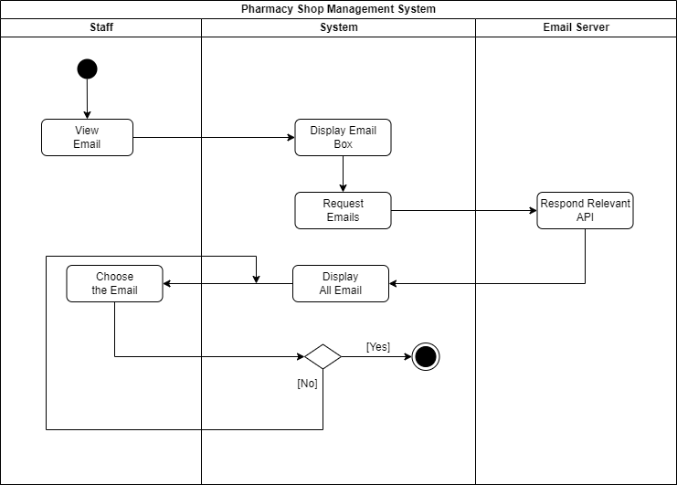

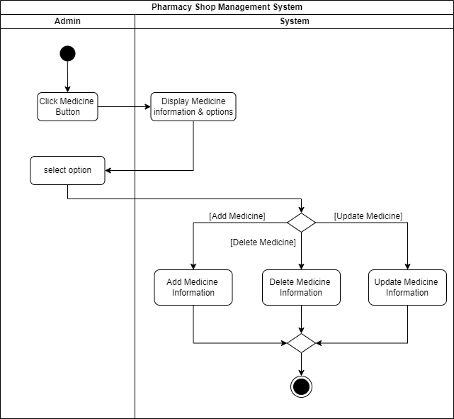

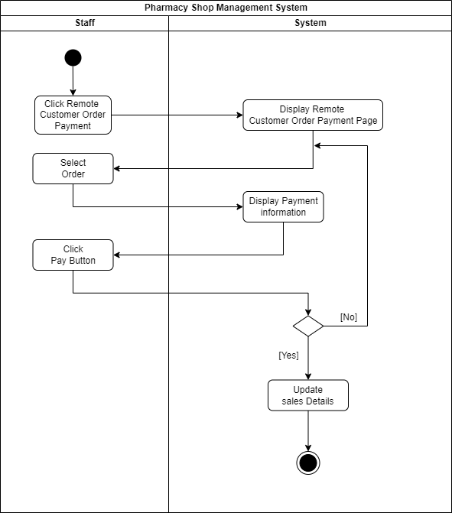

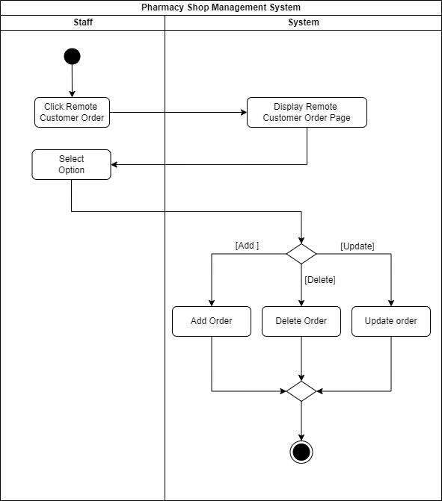

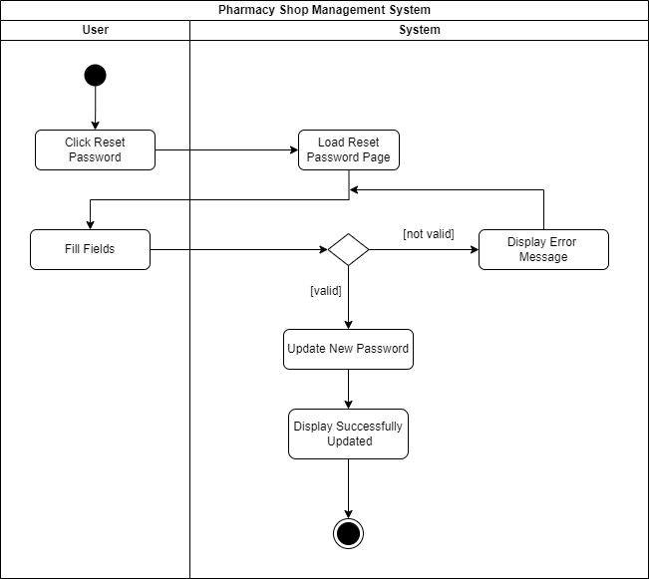

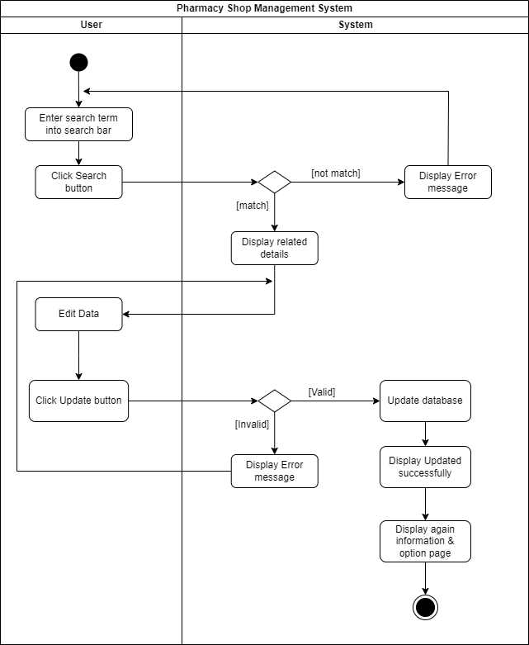

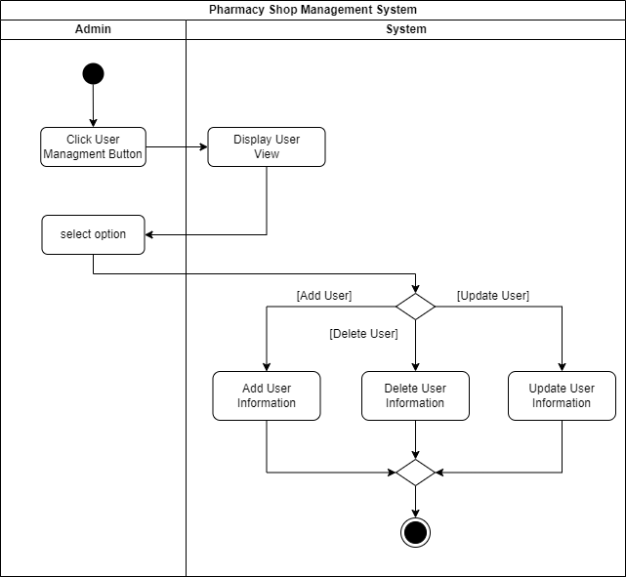

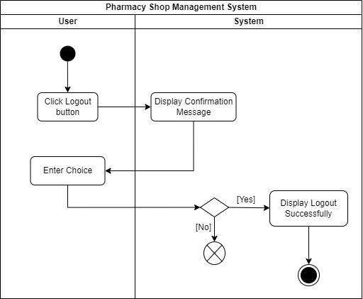

**2.4 Sequence Diagrams**

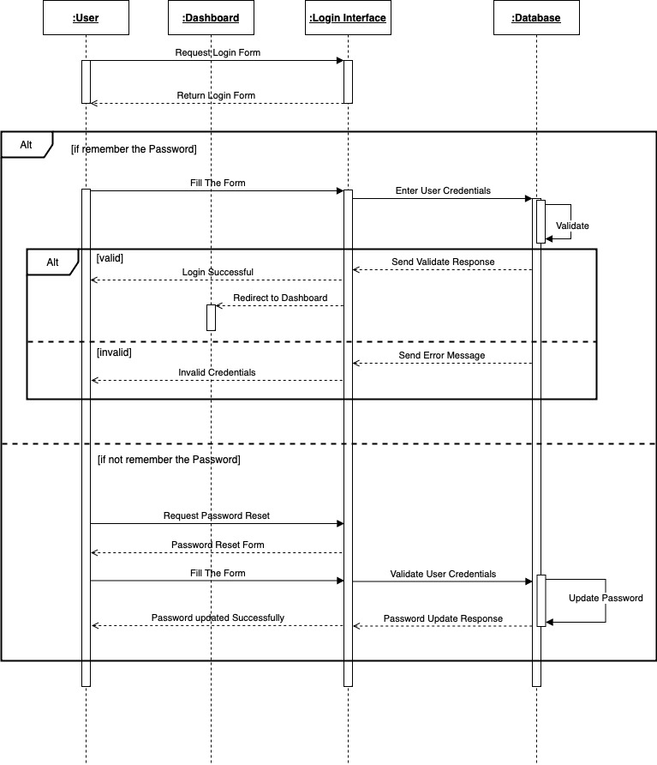

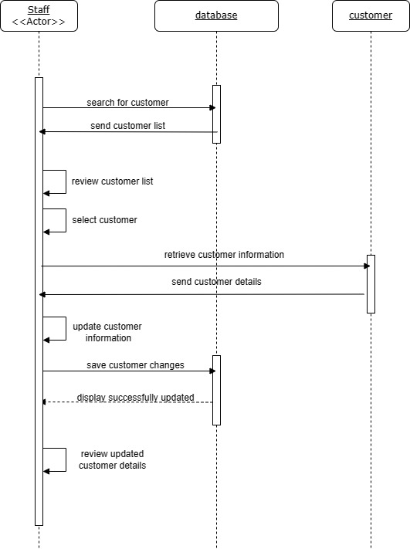

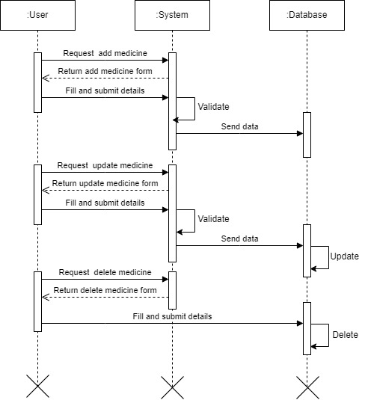

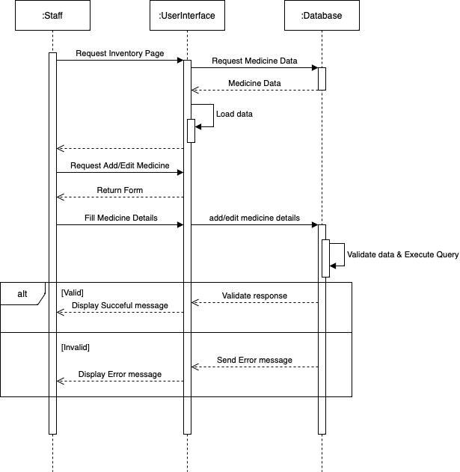

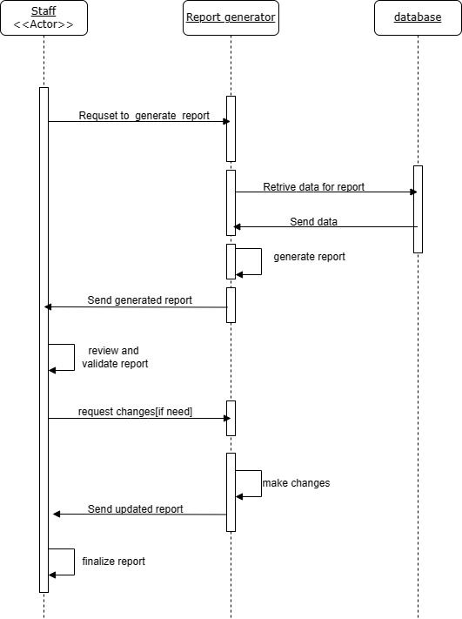

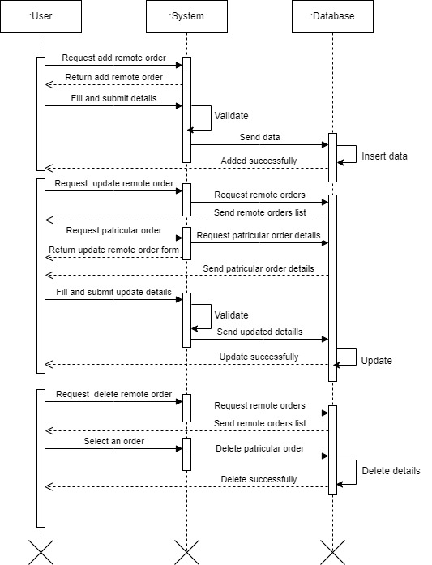

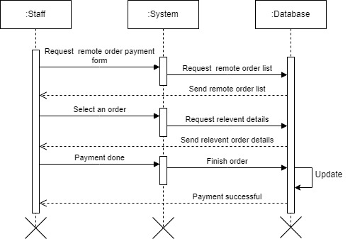

**2.5 ER Diagram**

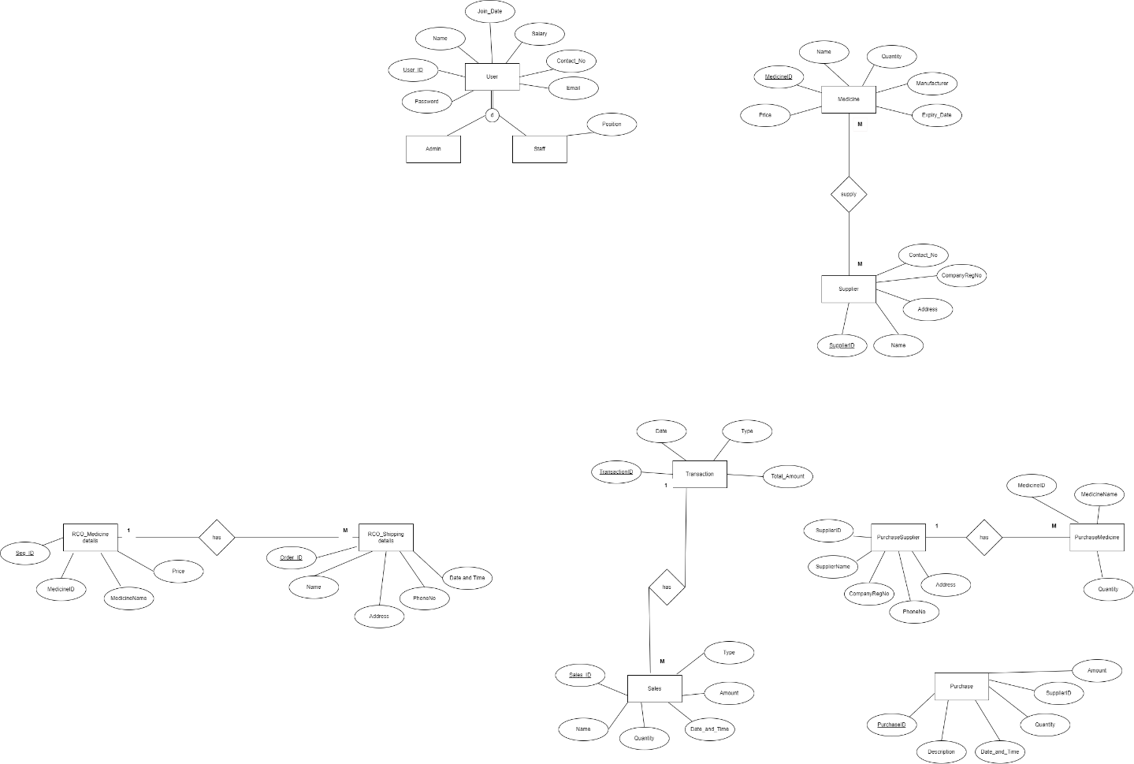

**2.6 Software Requirement Specification**

**Functional requirements**

|  |  |
| --- | --- |
| **ID** | **Description** |
| **Admin** | |
| 1 |  |
|  |  |
|  |  |
|  |  |
|  |  |
|  |  |